Improvisation Do’s and Don’ts and Notes
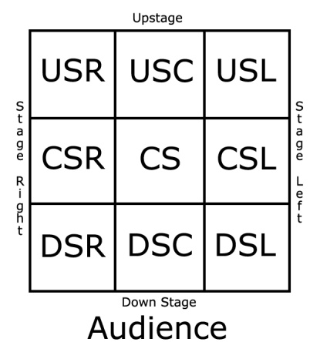
Do’s
- Take your cues from your scene partner.
- Play your scene from moment to moment.
- Allow your intuition to be your guide.
- Be spontaneous in your actions (no planning).
- Say or do things that demand a definite response.

Don’ts
- Never deny anything your scene partner says about you or the situation. If your partner says you have lovely yellow eyes, accept the statement as true and allow your imagination to help you respond.
- Avoid asking questions. Questions turn an improvisation into a question and answer routine. Especially avoid “terminal questions” – those that can be answered with a “yes” or “no” or with a response that shuts the down the flow of dialogue.
- Avoid simple statements of information. Make statements about your feelings and observations.
- Avoid explanations about situations and feelings. If you are happy, show it. If you are afraid of the dark, show that.
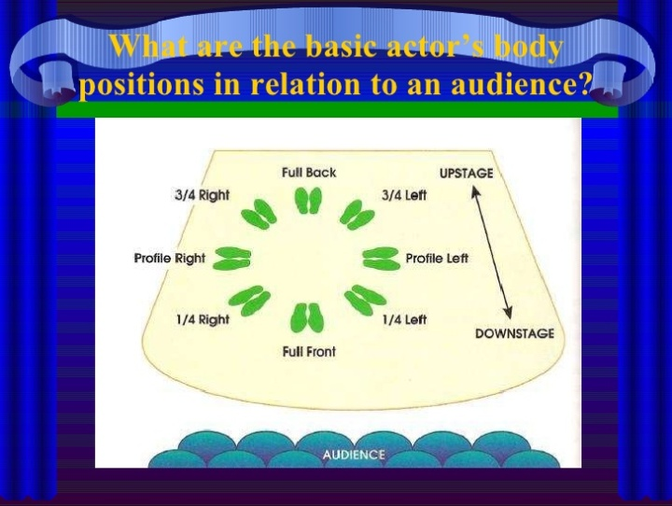
An actor can be on the stage in any of five basic positions, each conveying different psychological overtones.
  - Full-front (facing the camera): the position with the most intimacy. The character is looking in our direction, inviting our complicity.
  - Quarter Turn: the favored position of most filmmakers. This position offers a high degree of intimacy but with less emotional involvement than the full-front position.
  - Profile (looking of the frame left or right): More remote than the quarter turn, the character in profile seems unaware of being observed, lost in his or her own thoughts.
  - Three-quarter Turn: More anonymous than the profile, this position is useful for conveying a character's unfriendly or antisocial feelings, for in effect, the character is partially turning his or her back on us, rejecting our interest.

  - Back to Audience: The most anonymous of all positions, this position is often used to suggest a character's alienation from the world. When a character has his or her back to the camera, we can only guess what's taking place internally, conveying a sense of concealment, or mystery.

Improvisation Vocabulary
- Improvisation- is the impromptu portrayal of a character or scene without rehearsal or preparation.
- Spontaneity – is done or said in a natural and often sudden way and without a lot of thought or planning.
- Illusion of the first time – making the audience believe that each performance is the first.
- Scene stealing – to call attention to your presence when the focus should be on someone else
- Character centered approach – places a character or a group into several situations.
- Situation centered approach – take a single situation to demonstrate how different personalities will respond to the event.
- Motivated sequence – the natural way in which a person responds to an external stimulus, the brain registers, body responses and then reacts.

Key Vocabulary:  1. Character, role – the imaginary person, thing or animal the actor pretends to be on stage  2. Cue – a signal to begin action or dialogue  3. Dialogue- spoken words on stage  4. Downstage – a movement or area toward the audience  5. Duet scene- for two people  6. Exposition – information given through dialogue during a scene that explains events leading up to the action.  7. Actor-performer, player, or thespian on stage  8. Actor positions – terms that describe how directly the actor is facing.  9. Audience-people who watch, and/or listen and respond to the performances  - Gestures – a movement, usually of the arm, that helps to express an idea or feeling.  - Hand prop – a prop that can be easily handled. Examples: books, dishes, baseball bats.  - Improvisation – a scene performed with little or no rehearsal; it usually includes dialogue. | - Monologue, solo scene – a scene for one actor, who speaks his or her thoughts aloud or talks to an imaginary character or directly to the audience.  - Pantomime – a performance that communicat4es an idea or action without dialogue  - Set – the actual pieces of furniture, platforms or other items (or their lack) on the stage.  - Set prop – a large prop, such as a piece of furniture that is not easily moved.  - Setting – the imaginary place and time the stage area represents.  - Sight cue – visual signals for actors to begin action or dialogue or for the audience to quiet down for a performance  - Stage areas – for convenience, the acting area is divided into nine areas.  - Stage property – any item used on stage.  - A movement or area on the actor’s right as he or she faces the audience.  - Upstage – a movement or area away from the audience.

