Theatre Label Review Stage Directions
Name: _______________________________________
Theatre Stage Direction Labels:
Label the stage directions. You may use abbreviations.
A. | G. | B.
C. | H. | D.
I. | E. | F.

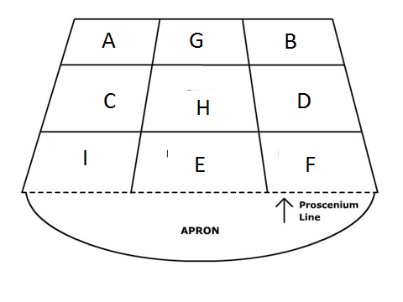

Body Directions Worksheet Review
Name: _________________________________________ Period: ____________ Date: ____________________

Label the Body Directions and two arrows pointing the position of the stage. Use the word bank below.
A. | F.
B. | G.
C. | H.
D. | I.
E. | J.
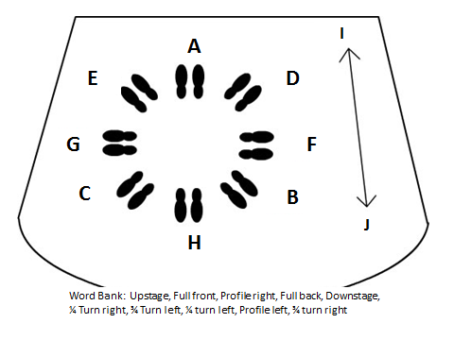

Proscenium Stage Diagram Worksheet
Name: _________________________________________ Period: ____________ Date: ____________________

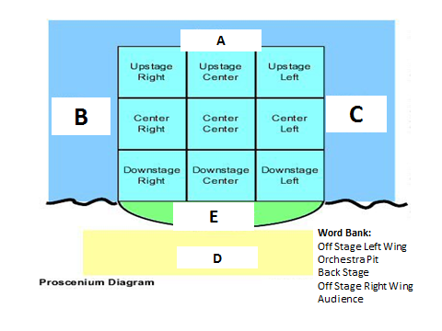
Label the correct parts of the stage diagram.

- _______________________________

- ________________________________

- _________________________________

- _________________________________

- _________________________________

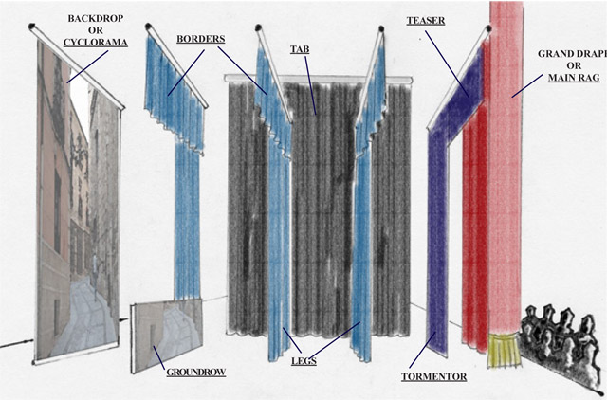
Proscenium Stage Diagram Worksheet
(New Information)
Name: _______________________________________ Period: ____________ Date: ____________________
Draw and label the curtain diagram in the box next to it. There is another bigger drawing on the back or the following page.

Stage Curtains
You will notice that each curtain section has a different name. Each curtain section services as a different function.

Questions about the curtains
- What function do you think each of these curtains have? Use your critical thinking skills to find your own definition. Remember, think about the audience and how your show could use these curtains. How would you use these curtains in your show? This may be different for each person.

  - Grand drape purpose –

  - Teaser –

  - Legs –

  - Tabs –

  - Borders –

  - Backdrop or Cyclorama -

